CALL FOR PAPERS
Metaphysical Society of America
2020 Annual Meeting at the College of the Holy Cross (Worcester, Massachusetts, March 19-22)

Theme: Nature and its Meanings
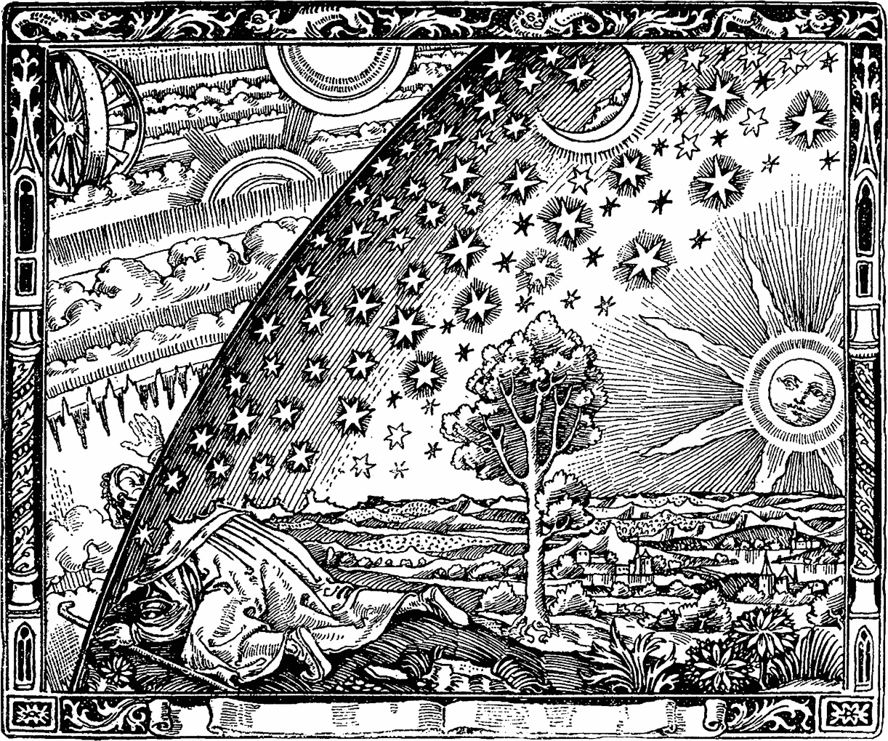
In 2020, the 70th anniversary of its founding, the theme of the Metaphysical Society of America’s annual meeting will be “Nature and its Meanings.” Papers treating any aspect of this wide issue, whether thematic or historical, are welcome. The following questions are some examples of what proposed papers might address.
* What is nature? How is nature to be understood metaphysically? What is the history and analysis of the concept of nature? What are “natures”? What is “non-natural” – the artificial, the cultural, the normative, the transcendental, the divine?
* What is naturalism? What are the kinds of naturalism, their virtues and their vices? What is (or are) the opposite(s) of naturalism? How is modern naturalism different from ancient and medieval naturalism? Is naturalism kin to atheism, materialism, physicalism, atomism, empiricism, nominalism, and positivism, and incompatible with theism, idealism, panpsychism, holism, rationalism, realism, and phenomenology? Or are those lists too simple? On which side would humanism go? What are the major disagreements among prominent naturalistic thinkers, from Aristotle to Hobbes, Mach to Quine, Whitehead to Santayana? Must naturalism be “reductive,” or can “non-reductive” approaches (e.g. Peirce, Bergson, Dewey, Teilhard De Chardin) be truly naturalistic? Can naturalism be found in putatively non-naturalistic thinkers, e.g. Plotinus, Spinoza, Leibniz, Schelling, Royce, Merleau-Ponty, and Deleuze?
* What is the relationship of metaphysics and modern natural science? What was the metaphysical view of nature bequeathed us by the 17th century scientist/philosophers? What are its merits and demerits today? What ought to be the role of the results of scientific inquiry in metaphysical speculation, if any? How has the science of the last century and a half, from biological evolution to relativity and quantum mechanics, altered the early modern picture? How have metaphysics and science altered each other – e.g. ethologist Lloyd Morgan’s impact on Samuel Alexander, biologist Jacob Von Uexküll’s on Heidegger, Whitehead’s influence on Conrad Waddington’s epigenetics? Ought recent work on “emergence,” the “disunity” of science, evolutionary biology, and complexity, systems, and hierarchy theory – associated with names like Donald Campbell, John Duprė, J. J. Gibson, Marjorie Grene, Stuart Kaufman, Ilya Prigogine, William Wimsatt – recast our metaphysical appraisal of natural science yet again?
* Can nature be conceived in ways that are compatible with mind, purpose, self, and free will? Is a naturalistic conception of human nature incompatible with, or uninformative for, understanding intentionality, meaning, experience, sociality, knowledge, or art? Can naturalistic approaches to human mind – for example in neuroscience and cognitive science – be incorporated into an adequate metaphysics of mind?
* Is modern naturalism, or any metaphysics rooted in the modern conception of nature, incompatible with normativity or the Good? Does the naturalistic fallacy in ethics still hold? Are naturalistic and evolutionary approaches to epistemology and logic plausible? Can “natural law” in political theory be compatible with scientific natural law? What is the relation of nature to aesthetic beauty?
* Do non-Western metaphysical traditions – e.g. Orthodox Christian, Chinese, Japanese, South Asian, Islamic, African, Indigenous American – present novel conceptual and cultural resources for understanding nature? Where does Western naturalism, and particularly modern Western naturalism, fail by their standards?
* Must naturalism reject God? Is it inherently anti-supernatural, or incompatible with divinity and religion? Must the divine, the transcendent, or the sacred be external to nature? (Or, if nature and God are synthesized, must pan(en)theism endorse a very un-naturalistic notion of nature?) Which conceptions of God or gods are compatible, and which incompatible, with modern naturalism? What relation can be asserted between the eternal and the temporal?
* Do ecology and environmental studies suggest a novel metaphysical perspective? What metaphysics is most appropriate for an ecologically concerned philosophy? What is the place of animal “values,” “goods” or “rights” in a naturalistic account of the world?
* Can metaphysics recast or repair the methodological conflict of the humanities and social sciences with the natural sciences? Is the continuing division of inquiry into C.P. Snow’s “the two cultures,” and with it the century-long battle in the social sciences between the adoption of natural scientific versus “humanistic” or “hermeneutic” methods, unavoidable? Can the metaphysics of nature put this conflict in another light?
* Must current political conceptions, such as feminism, critical race theory, and queer theory, find biological or naturalist theories of human being antithetical? Or is that opposition mistaken? Can the notions of the human person characteristic of these views be compatible with a naturalistic, e.g. biological and evolutionary, context?
------------------------------------------------
Please send one abstract of approximately 500 words, with title but no name, and a second file containing title, your name, and contact information, electronically by September 1, 2019 to Lawrence Cahoone, Professor of Philosophy, College of the Holy Cross at: lcahoone@holycross.edu The Program Committee will then select the conference papers. Those whose abstracts are chosen should submit completed papers by January 15, 2020 to allow review by commentators and publication of the program. Further information on the conference will become available at: www.metaphysicalsociety.org

Aristotle Prize: Papers submitted by persons who have not yet earned a Ph.D. or who have received a Ph.D. within five years of the submission date will be considered for the Aristotle prize, if the Program Committee is made aware of their eligibility. The prize carries a cash award of $500, inclusion in the program, and assistance with the costs associated with attending the meeting. Graduate students and recent Ph.D.s are encouraged to apply. Full papers must be submitted for the prize by September 1, 2019.
Travel Grants for Graduate Students: Thanks to the generous support of past presidents of the MSA and a grant from the Hocking-Cabot Fund for Systematic Philosophy, we are pleased to offer travel grants to graduate students whose papers are selected for the program for our annual meeting. More information and an application can be found on the Society’s website.
Conference Registration: Note, it is not necessary to register for the conference to submit a paper, but it is necessary in order to deliver it.

